**VISVESVARAYA TECHNOLOGICAL UNIVERSITY**

**“Jnana Sangama”, Belagavi-590018**



**DBMS MINI PROJECT**

**REPORT ON**

**“ONLINE FOOD ORDER MANAGEMENT SYSTEM”**

*Submitted in partial fulfillment of the requirements for the award of the degree of*

**BACHELOR OF ENGINEERING**

IN

**COMPUTER SCIENCE AND ENGINEERING**

Submitted by

**SUHAIL AHMED SAYYED(1KG19CS100)**

**PRAKRIT BASNET (1KG19CS065)**

Under the Guidance of

**Mrs.Amitha S**

Assistant Professor

Department of CSE

K.S.S.E.M



**Department of Computer Science &Engineering**

**K. S. SCHOOL OF ENGINEERING AND MANAGEMENT**

#15, Mallasandra, off. Kanakapura Road, Bengaluru – 560109

**2021-2022**

**K. S. SCHOOL OF ENGINEERING AND MANAGEMENT**

**BENGALURU - 560109**

**Department of Computer Science &Engineering**



**CERTIFICATE**

This is to certify that the **DBMS MINI PROJECT** entitled **“ONLINE FOOD ORDER MANAGEMENT SYSTEM”** presented by **Mr. Suhail Ahmed Sayyed** **,USN: 1KG19CS100, Mr.Prakrit Basnet, USN:1KG19CS065** of **V semester** in partial fulfillment of the award of **Bachelor of Engineering** in **Computer Science & Engineering** in **Visvesvaraya Technological University**, Belagavi during the academic year **2021-2022**. The **DBMS MINI PROJECT** has been approved as it satisfies the academic requirements in respect of **DBMS Mini Project(18CSL58)** prescribed for the Bachelor of Engineering degree.

**--------------------- ----------------------- ------------------------**

**Mrs. Amitha S . Dr.K Venkat Rao Dr.K.RAMANARASIMHA**

**­­­­­­­­­­­­Assistant Professor, CSE Associate Prof. & Head, CSE Principal / Director**

**K.S.S.E.M., Bengaluru K.S.S.E.M., Bengaluru K.S.S.E.M., Bengaluru**

**Name of the Student: Suhail Ahmed Sayyed** **Prakrit Basnett**

**USN: 1KG19CS100 1KG19CS065**

**Signature of the Student:**

**Name of the examiners Signature with date**

**1**.

**2**.

**ACKNOWLEDGEMENT**

The successful presentation of the **DBMS MINI PROJECT** would be incomplete without the mention of the people who made it possible and whose constant guidance crowned my effort with success.

We would like to extend my gratitude to the **MANAGEMENT, KAMMAVARI SANGHAM**, Bengaluru, for providing all the facilities to present the DBMS Mini Project.

We would like to extend my gratitude to **Dr. K. RAMA NARASIMHA,** Principal / Director, K. S. School of Engineering and Management, Bengaluru, for facilitating me to present the Web Technology Mini Project.

We thank **Dr. K Venkata Rao**, Professor and Head, Department of Computer Science and Engineering, K. S. School of Engineering and Management, Bengaluru, for his encouragement.

We would like to thank our Project Guide, **Mrs. Amitha S.**, Assistant Professor, Department of Computer Science and Engineering, K. S. School of Engineering and Management, Bengaluru, for her constant guidance and inputs.

We would like to thank all the **Teaching** Staff and **Non-Teaching** Staff of the college for their co-operation.

Finally, we extend my heart-felt gratitude to my family for their encouragement and support without which we would not have come so far. Moreover, we thank all my friends for them invaluable support and cooperation.

**SUHAIL AHMED SAYYED 1KG19CS100**

**PRAKRIT BASNET 1KG19CS065**

**ABSTRACT**

The main objective of this system is to manage the details of item category, food, delivery address, order, and shopping cart. It manages all the information about item category, customer, shopping cart, item category. The project is totally built at administrative end and thus only the administrator is guaranteed the access. The purpose is to build and application program to reduce the managing the item category, food customers. It tracks all he delivery address ordered.

Helps customer to order their food at any time. The customers will be able to order their favorite dishes at any point of time, and as we have pointed out earlier, that time is a minimal option, and restaurants must have a specified system through which they can serve a huge number of customers while making their work smoother. Ordering.co is one of the best platforms which provides all of these platforms along with numerous innovative features which has turned countless small and large businesses into an inspiring leader in the online marketplace.

# TABLE OF CONTENTS

|  |  |  |
| --- | --- | --- |
| **Chapter No.** | **Contents** | **Page No.** |
|  | Acknowledgement | I |
|  | Abstract | II |
|  | Table of Contents | III |
|  | List of Figures | IV |
|  | List of Tables | V |
| **Chapter 1** | **INTRODUCTION** | 1 |
| 1.1 | INTRODUCTION | 1 |
| 1.2 | OBJECTIVE | 1 |
| 1.3 | NEEDS OF ONLINE FOOD ORDER | 1 |
| 1.4 | METHODOLOGY DEVELOPMENT MODEL | 2 |
| 1.5  1.6 | TOOLS AND TECHNIQUE  EXTERNAL INTERFACES | 3 |
| **Chapter 2** | **TASK AND ACTIVITIES PERFORMED** | 4 |
| 2.1 | PROFILE OF PROBLEMS | 4 |
| 2.2 | STRUCTURE OF THE PROJECT | 4 |
| 2.3 | SCOPE AND FEASIBILITY | 4 |
| 2.4 | SYSTEM ANALYSIS | 4 |
| 2.5  2.6 | SYSTEM DESIGN  IMPLEMENTATION | 5 |
| **Chapter 3** |  |  |
| 3.1 | ENTITY RELATIONSHIP DIAGRAM | 7 |
| 3.3 | RELATIONAL SCHEMA | 10 |
| 3.4 | DESCRIPTION OF TABLES | 11 |
| **Chapter 4** |  |  |
| 4.3 | RESULT | 23 |
| **Chapter 5** | TESTING | 24 |
| 5.1 | SOFTWARE TESTING | 24 |
| 5.2 | MODULE TESTING AND INTEGRATION | 24 |
| **Chapter 6** | SNAP SHOTS | 26 |
| 6.1 | LOGIN PAGE | 26 |

|  |  |  |
| --- | --- | --- |
| 6.2 | DASHBOARD | 26 |
| 6.3 | ADDING NEW CUSTOMERS | 27 |
| 6.4 | ADDING NEW SUPPLIER | 27 |
| 6.5 | ADDING NEW PURCHASE | 28 |
| 6.6 | MEDICINAL STOCKS | 28 |
| 6.7 | MANAGING INVOICE | 29 |
| **Chapter 8** | CONCLUSION | 30 |
| **Chapter 9** | FUTURE ENHANCEMENTS | 31 |
|  | REFERENCES  **LIST OF FIGURES:**  1. JSP Architecture 6  2. ER diagram of pharmacy DBMS 10  3. Relational schema 11 | 32 |

Chapter 1:Introduction

**1.1 INTRODUCTION**

**Online food ordering** is the process of ordering food from a website .The product can be either ready-to-eat food (e.g., direct from a certified home-kitchen, restaurant) or food that has not been specially prepared for direction consumption (e.g., vegetables direct from a farm/garden, frozen meats. etc).The aim of developing Online Food Ordering system project is to replace the traditional way of taking orders with computerized system. Another important reason for developing this project is to prepare order summary reports quickly and in correct format at any point of time when required.

Online Food Ordering System has a very lot of scope. This PHP project can be used by any restaurants or fast foods for customers for keeping their order records. This project is easy, fast and accurate. It requires less disk space. Online Food Ordering System uses MYSQL Server as backend so there is not any chance of data loss or data security. A customer can choose to have the food delivered or for pick-up. The process consists of a customer choosing the restaurant of their choice, scanning the menu items, choosing an item, and finally choosing for pick-up or delivery. Payment is then administered by paying with a credit card or debit card through the app or website or in cash at the restaurant when going to pickup. The website and app inform the customer of the food quality, duration of food preparation, and when the food is ready for pick-up or the amount of time it will take for delivery

## **1.2 Objective**

The main objective of this system is to manage the details of item category, food, delivery address, order, and shopping cart. It manages all the information about item category, customer, shopping cart, item category. The project is totally built at administrative end and thus only the administrator is guaranteed the access. The purpose is to build and application program to reduce the managing the item category, food customers. It tracks all he delivery address ordered.

# 

* 1. Needs of Online Food Order

Helps customer to order their food at any time. The customers will be able to order their favorite dishes at any point of time, and as we have pointed out earlier, that time is a minimal option, and restaurants must have a specified system through which they can serve a huge number of customers while making their work smoother. Ordering.co is one of the best platforms which provides all of these platforms along with numerous innovative features which has turned countless small and large businesses into an inspiring leader in the online marketplace.

1.4 Methodology Development Model

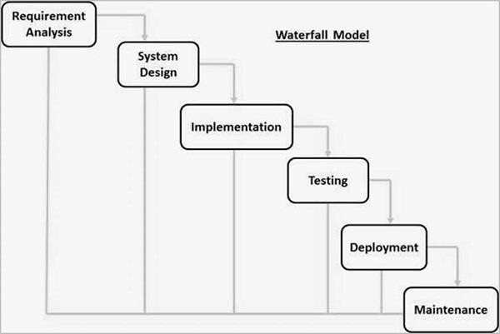

The sequential phases in Waterfall model are −

**Requirement Gathering and analysis** − All possible requirements of the system to be developed are captured in this phase and documented in a requirement specification document.

* + - **System Design** − The requirement specifications from first phase are studied in this phase and the system design is prepared. This system design helps in specifying hardware and system requirements and helps in defining the overall system architecture.
    - **Implementation** − With inputs from the system design, the system is first developed in small programs called units, which are integrated in the next phase. Each unit is developed and tested for its functionality, which is referred to as Unit Testing.
    - **Integration and Testing** − All the units developed in the implementation phase are integrated into a system after testing of each unit. Post integration the entire system is tested for any faults and failures.
    - **Deployment of system** − Once the functional and non-functional testing is done; the product is deployed in the customer environment or released into the market.
    - **Maintenance** − There are some issues which come up in the client environment. To fix those issues, patches are released. Also to enhance the product some better versions are released. Maintenance is done to deliver these changes in the customer environment.

1.5 Tools and Technique

1. Xampp
2. HTML
3. Bootstrap
4. Sublime text
5. Git hub
6. Java Script
7. Css

**PHP**

**Hypertext Preprocessor** (or simply **PHP**) is a [server-side scripting](https://en.wikipedia.org/wiki/Server-side_scripting) language designed for [Web](https://en.wikipedia.org/wiki/Web_development) [development,](https://en.wikipedia.org/wiki/Web_development) but also used as a [general-purpose programming language.](https://en.wikipedia.org/wiki/General-purpose_programming_language) It was originally created

by [Rasmus Lerdorf](https://en.wikipedia.org/wiki/Rasmus_Lerdorf) in 1994[,]](https://en.wikipedia.org/wiki/PHP#cite_note-History_of_PHP-5) the PHP [reference implementation](https://en.wikipedia.org/wiki/Reference_implementation) is now produced *by* The PHP Group. PHP originally stood for Personal *Home Page*[,]](https://en.wikipedia.org/wiki/PHP#cite_note-History_of_PHP-5) but it now stands for the [recursive acronym](https://en.wikipedia.org/wiki/Recursive_acronym) *PHP: Hypertext Preprocessor*.

PHP code may be embedded into [HTML](https://en.wikipedia.org/wiki/HTML) code, or it can be used in combination with various [web](https://en.wikipedia.org/wiki/Web_template_system) [template systems,](https://en.wikipedia.org/wiki/Web_template_system) web content management systems, and [web frameworks](https://en.wikipedia.org/wiki/Web_framework). PHP code is usually processed by a PHP [interpreter](https://en.wikipedia.org/wiki/Interpreter_(computing)) implemented as a [module](https://en.wikipedia.org/wiki/Plugin_(computing)) in the web server or as a [Common Gateway](https://en.wikipedia.org/wiki/Common_Gateway_Interface) [Interface](https://en.wikipedia.org/wiki/Common_Gateway_Interface) (CGI) executable. The web server combines the results of the interpreted and executed PHP code, which may be any type of data, including images, with the generated web page. PHP code may also be executed with a [command-line interface](https://en.wikipedia.org/wiki/Command-line_interface) (CLI) and can be used to implement [standalone](https://en.wikipedia.org/wiki/Computer_software) [graphical applications](https://en.wikipedia.org/wiki/Graphical_user_interface).

**XAMPP**

XAMPP is a [free and open source](https://en.wikipedia.org/wiki/Free_software) [cross-platform](https://en.wikipedia.org/wiki/Cross-platform) [web server](https://en.wikipedia.org/wiki/Web_server) [solution stack](https://en.wikipedia.org/wiki/Solution_stack) package developed by Apache Friends, consisting mainly of the [Apache HTTP Server,](https://en.wikipedia.org/wiki/Apache_HTTP_Server) [MariaDB](https://en.wikipedia.org/wiki/MariaDB) [database](https://en.wikipedia.org/wiki/Database), and [interpreters](https://en.wikipedia.org/wiki/Interpreter_(computing)) for scripts written in the [PHP](https://en.wikipedia.org/wiki/PHP) and [Perl](https://en.wikipedia.org/wiki/Perl) [programming languages](https://en.wikipedia.org/wiki/Programming_language). XAMPP stands for Cross-Platform (X), Apache (A), MariaDB (M), PHP (P) and Perl (P). It is a simple, lightweight Apache distribution that makes it extremely easy for developers to create a local web server for testing and deployment purposes. Everything needed to set up a web server – server application (Apache), database (MariaDB), and scripting language (PHP) – is included in an extractable file. XAMPP is also cross-platform, which means it works equally well onLinux, Mac and Windows.

Since most actual web server deployments use the same components as XAMPP, it makes transitioning from a local test server to a live server extremely easy as well.

**MYSQL YOG**

MySQL Workbench is a unified visual tool for database architects, developers, and DBAs. MySQL Workbench provides data modeling, SQL development, and comprehensive administration tools for server configuration, user administration, backup, and much more. MySQL Workbench is available on Windows, Linux and Mac OS X.

**HTML**

Hypertext Markup Language (HTML) is the standard [markup language](https://en.wikipedia.org/wiki/Markup_language) for creating [web pages](https://en.wikipedia.org/wiki/Web_page) and [web](https://en.wikipedia.org/wiki/Web_application) [applications.](https://en.wikipedia.org/wiki/Web_application) With [Cascading Style Sheets](https://en.wikipedia.org/wiki/Cascading_Style_Sheets) (CSS) and [JavaScript](https://en.wikipedia.org/wiki/JavaScript), it forms a triad of cornerstone technologies for the [World Wide Web](https://en.wikipedia.org/wiki/World_Wide_Web)[.[4]](https://en.wikipedia.org/wiki/HTML#cite_note-4)

[Web browsers](https://en.wikipedia.org/wiki/Web_browser) receive HTML documents from a [web server](https://en.wikipedia.org/wiki/Web_server) or from local storage and [render](https://en.wikipedia.org/wiki/Browser_engine) the documents into multimedia web pages. HTML describes the structure of a web page [semantically](https://en.wikipedia.org/wiki/Semantic_Web) and originally included cues for the appearance of the document.

[HTML elements](https://en.wikipedia.org/wiki/HTML_element) are the building blocks of HTML pages. With HTML constructs, [images](https://en.wikipedia.org/wiki/HTML_element#Images_and_objects) and other objects such as [interactive forms](https://en.wikipedia.org/wiki/Fieldset) may be embedded into the rendered page. HTML provides a means to

create [structured documents](https://en.wikipedia.org/wiki/Structured_document) by denoting structural [semantics](https://en.wikipedia.org/wiki/Semantics) for text such as headings, paragraphs, lists, [links,](https://en.wikipedia.org/wiki/Hyperlink) quotes and other items.

**BOOTSTRAP**

Bootstrap is a [free and open-source](https://en.wikipedia.org/wiki/Free_and_open-source_software) front-end framework for designing [websites](https://en.wikipedia.org/wiki/Website) and [web applications](https://en.wikipedia.org/wiki/Web_application). It contains [HTML](https://en.wikipedia.org/wiki/HTML)- and [CSS](https://en.wikipedia.org/wiki/CSS)-based design templates for [typography](https://en.wikipedia.org/wiki/Typography), forms, buttons, navigation and other interface components, as well as optional [JavaScript](https://en.wikipedia.org/wiki/JavaScript) extensions. Unlike many web frameworks, it concerns itself with [front-end development](https://en.wikipedia.org/wiki/Front-end_web_development) only.

**Java Script**

JavaScript often abbreviated as JS, is a [high-level,](https://en.wikipedia.org/wiki/High-level_programming_language) [interpreted](https://en.wikipedia.org/wiki/Interpreted_language) [programming language](https://en.wikipedia.org/wiki/Programming_language). It is a language which is also characterized as [dynamic,](https://en.wikipedia.org/wiki/Dynamic_programming_language) [weakly typed,](https://en.wikipedia.org/wiki/Weak_typing) [prototype-based](https://en.wikipedia.org/wiki/Prototype-based_programming) and [multi-paradigm](https://en.wikipedia.org/wiki/Multi-paradigm_programming_language).

Alongside [HTML](https://en.wikipedia.org/wiki/HTML) and [CSS,](https://en.wikipedia.org/wiki/CSS) JavaScript is one of the three core technologies of the [World Wide](https://en.wikipedia.org/wiki/World_Wide_Web)

[Web.](https://en.wikipedia.org/wiki/World_Wide_Web) JavaScript enables interactive [web pages](https://en.wikipedia.org/wiki/Web_page) and thus is an essential part of [web applications](https://en.wikipedia.org/wiki/Web_application). The vast majority of [websites](https://en.wikipedia.org/wiki/Website) use it, and all major [web browsers](https://en.wikipedia.org/wiki/Web_browser) have a dedicated [JavaScript engine](https://en.wikipedia.org/wiki/JavaScript_engine) to execute it.

**Sublime Text**

Sublime Text is a [proprietary](https://en.wikipedia.org/wiki/Proprietary_software) [cross-platform](https://en.wikipedia.org/wiki/Cross-platform) [source code editor](https://en.wikipedia.org/wiki/Source_code_editor) with a [Python](https://en.wikipedia.org/wiki/Python_(programming_language)) [application programming](https://en.wikipedia.org/wiki/Application_programming_interface) [interface](https://en.wikipedia.org/wiki/Application_programming_interface) (API). It natively supports many [programming languages](https://en.wikipedia.org/wiki/Programming_languages) and [markup languages,](https://en.wikipedia.org/wiki/Markup_languages) and functions can be added by users with [plugins,](https://en.wikipedia.org/wiki/Plugins) typically community-built and maintained under [free-software](https://en.wikipedia.org/wiki/Free_software_licenses) [licenses.](https://en.wikipedia.org/wiki/Free_software_licenses)

**Github**

GitHub is a web-based [hosting service](https://en.wikipedia.org/wiki/Internet_hosting_service) for [version control](https://en.wikipedia.org/wiki/Version_control) using [Git.](https://en.wikipedia.org/wiki/Git) It is mostly used for [computer code.](https://en.wikipedia.org/wiki/Source_code) It offers all of the [distributed version control](https://en.wikipedia.org/wiki/Distributed_version_control) and [source code management](https://en.wikipedia.org/wiki/Source_code_management) (SCM) functionality of Git as well as adding its own features. It provides [access control](https://en.wikipedia.org/wiki/Access_control) and several collaboration features such as [bug](https://en.wikipedia.org/wiki/Bug_tracking_system)

[tracking,](https://en.wikipedia.org/wiki/Bug_tracking_system) [feature requests,](https://en.wikipedia.org/wiki/Software_feature) [task management,](https://en.wikipedia.org/wiki/Task_management) and [wikis](https://en.wikipedia.org/wiki/Wiki) for every project.

GitHub offers plans for both private repositories and free accounts which are commonly used to host [open-](https://en.wikipedia.org/wiki/Open-source) [source](https://en.wikipedia.org/wiki/Open-source) software project

**Css**

Cascading Style Sheets (CSS) is a [style sheet language](https://en.wikipedia.org/wiki/Style_sheet_language) used for describing the [presentation](https://en.wikipedia.org/wiki/Presentation_semantics) of a document written in a [markup language](https://en.wikipedia.org/wiki/Markup_language) like [HTML.](https://en.wikipedia.org/wiki/HTML) CSS is a cornerstone technology of the [World Wide](https://en.wikipedia.org/wiki/World_Wide_Web) [Web,](https://en.wikipedia.org/wiki/World_Wide_Web) alongside HTML and [JavaScript.](https://en.wikipedia.org/wiki/JavaScript)

CSS is designed to enable the separation of presentation and content, including [layout](https://en.wikipedia.org/wiki/Page_layout), [colors](https://en.wikipedia.org/wiki/Color),

and [fonts.](https://en.wikipedia.org/wiki/Typeface) This separation can improve content [accessibility,](https://en.wikipedia.org/wiki/Accessibility) provide more flexibility and control in the specification of presentation characteristics, enable multiple [web pages](https://en.wikipedia.org/wiki/Web_page) to share formatting by specifying the relevant CSS in a separate css file, and reduce complexity and repetition in the structural content.

1.6 Specification Requirement

1.6.1 External Interfaces

- This interface will be actual interface through which the user will communication with the application and perform the desired tasks.

Admin login

**I.D:**

**Role**: Admin wishes to login to the system

**Precondition**: Username and Password

**Success end Condition**: Main option of screen display

**Failed end Condition**: User has entered incorrect Username and

Edit

I.D:

**Precondition:** User has successfully navigated to the search result

**Success end Condition:** User has successfully made the changes

1. To edit user records in the data base, first search the record you want to edit then click on ‘edit’ button.
2. Edit the particulars user that you want to change and click on’ Save’ button.

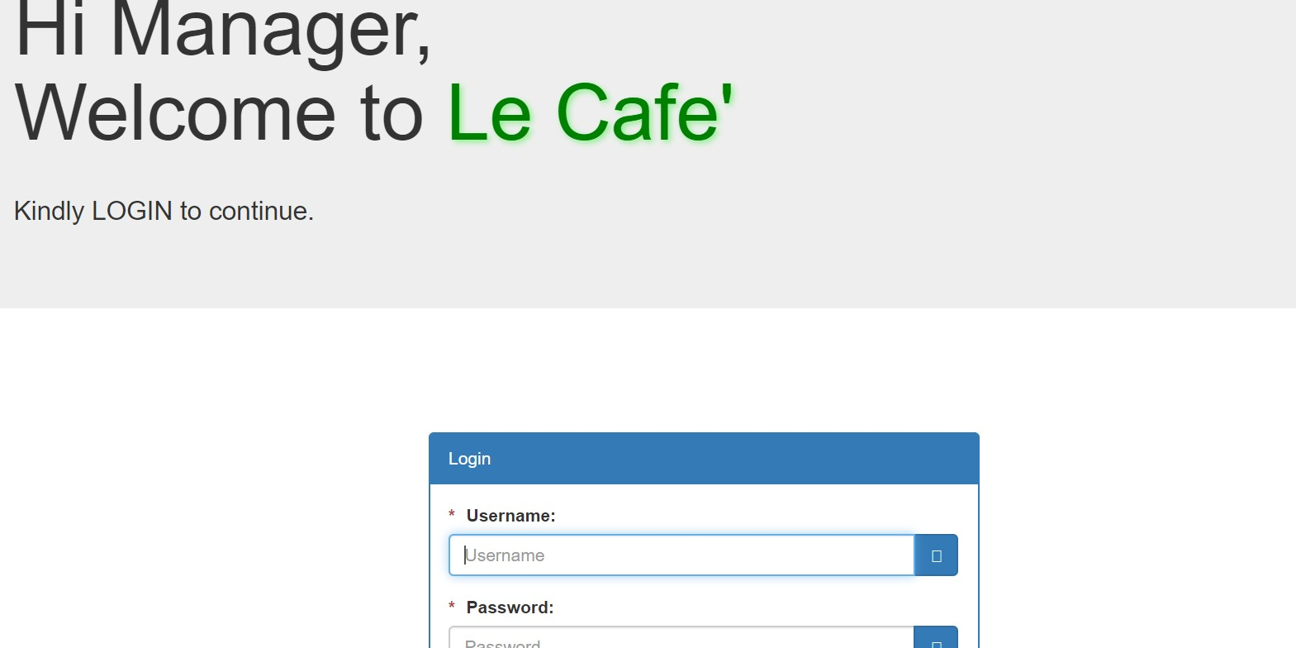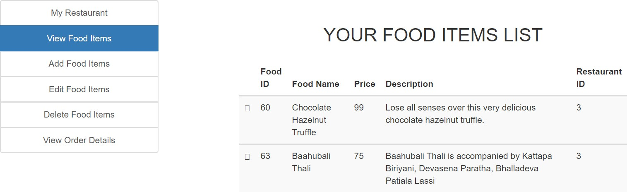

**1.6.1 Software Product Features**

Online Food Order

Login Information System

* Description

-The system will maintain the login information of its user to enter in to the software

* Validating Checks

-Administrator need to login the unique id and password.

-Contact number should have maximum 10 digits.

-All the details must be fill up.

-Email address should be in the proper format.

* Sequencing information

-Login information should be filled before the user allowed.

* Error Handling

-If user doesn’t filled up validate information then the system display error

Performance required

* Security

-System should be Protected from unauthorized access Where the validate Username and Password are required so no other can access.

* Maintainability

-System should be design in a maintain order. So it can be easily modified.

Logical Database

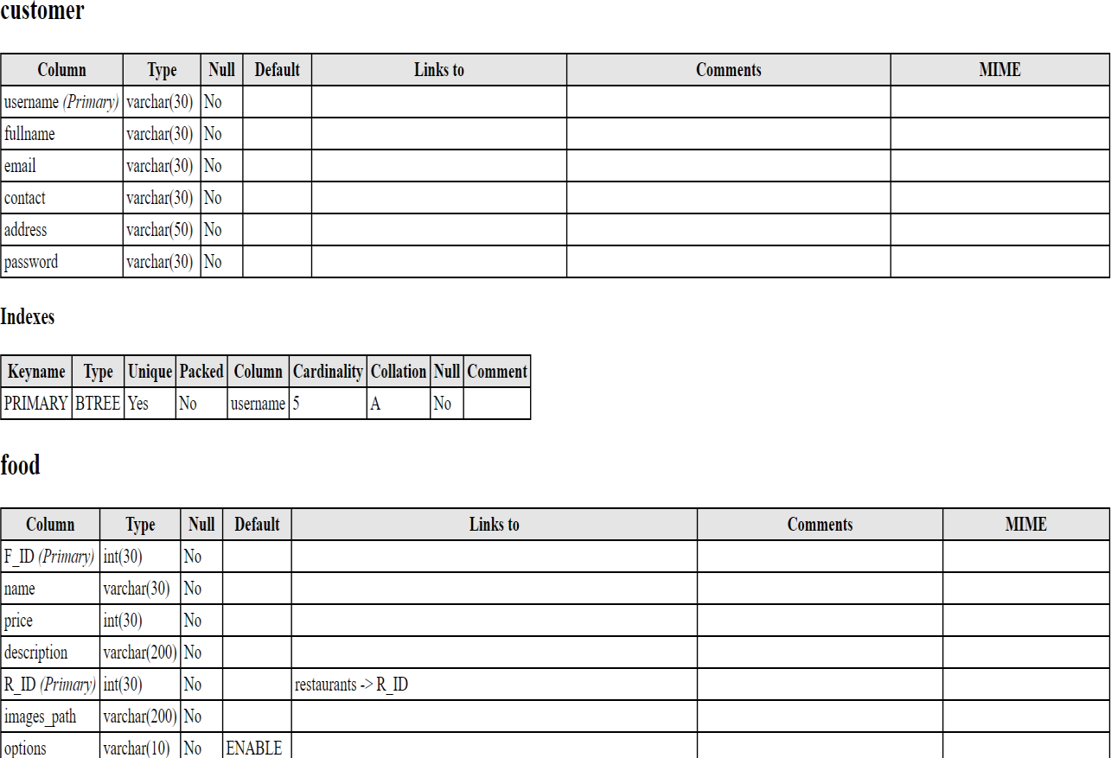

Data Model: A database model is a type of data model that determines the logical structure of a database and fundamentally determines in which manner data can be stored, organized and manipulated.

Level 0

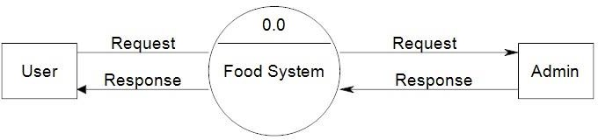 Figure: Data flow

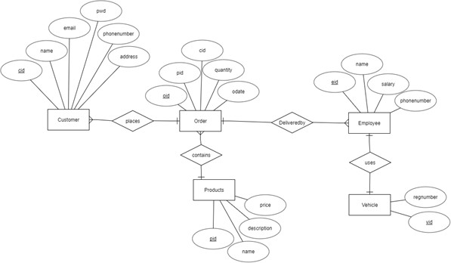

Figure:ER diagram

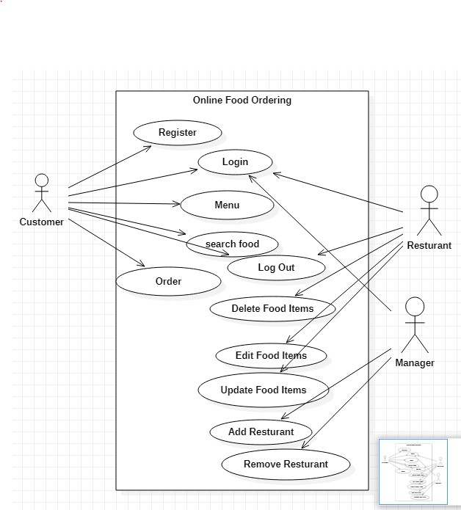

Schema

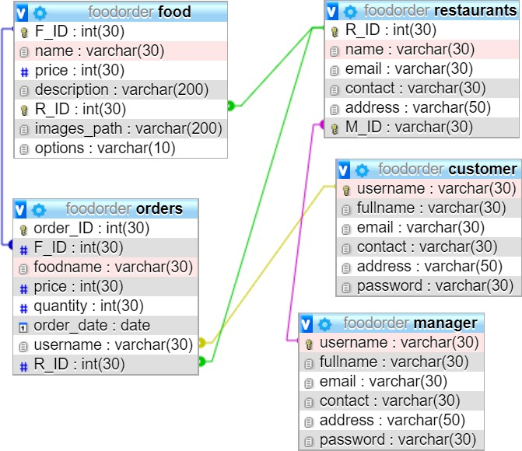

Figure: Use case Diagram of Ecommerce

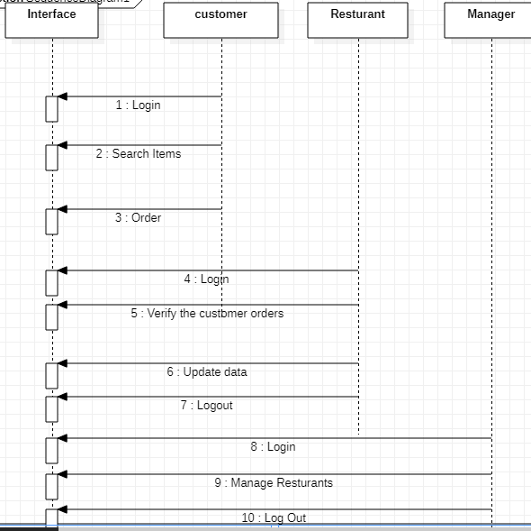

Figure: Schema Diagram

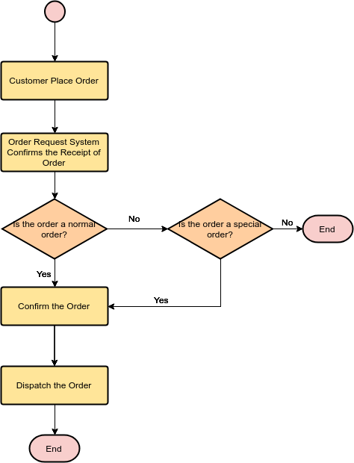

Figure: Flowchart of Ecommerce

Chapter II: Task and Activities Performed

2.1 Profile of Problems

In the present system all work is done on paper. The order report, food category and food are stored in register and at the end of the session the reports are generated. We are not interested in generating report in the middle of the session or as per the requirement because it takes more time in calculation. The existing system is not user friendly because the retrieval of data is very slow and data is not maintained efficiently. We require more calculations to generate the report so it is generated at the end of the session. All calculations to generate report is done manually so there is greater chance of errors.

2.2 Structure of the project

* Before Login
  + Login
  + Register
  + Administrator Login
  + About Us
  + Contact Us
* After Administrator Login
  + Edit Website Details
  + Add Food Items
  + Remove food Items
  + Add Restaurants
  + Delete Restaurant
  + Logout
* After User Login
  + My Profile
  + Menu
  + Search Food Items
  + My Cart
  + Order
  + Logout

2.3 Scope and Feasibility

This activity is also known as the feasibility study. It begins with a request from the user for a new system. It involves the following:

* + - Identify the responsible user for a new system
    - Clarify the user request
    - Identify deficiencies in the current system
    - Establish goals and objectives for the new system
    - Determine the feasibility for the new system
    - Prepare a project charter that will be used to guide the remainder of the Project

2.4 System Analysis

It is a process of collecting and interpreting facts, identifying the problems, and decomposition of a system into its components.

System analysis is conducted for the purpose of studying a system or its parts in order to identify its objectives. It is a problem solving technique that improves the system and ensures that all the components of the system work efficiently to accomplish their purpose.

The objective of the system analysis activity is to develop structured system specification for the proposed system. The structured system specification should describe what the proposed system

would do; independent of the technology, which will be used to implement these requirements. The structured system specification will be used to implement these requirements.

The essential model may itself consist of multiple models, modeling different aspect of the system. The data flow diagrams may model the data and there relationships and the state transition diagram may model time dependent behavior of the system. The essential model thus consists of the following.

* + - Context diagram
    - Leveled data flow diagrams
    - Process specification for elementary bubbles
    - Data dictionary for the flow and stores on the DFDs.

2.5 System Design

System design involves transformation of the user implementation model into software design. The design specification of the proposed system consists of the following:

* + - Database scheme
    - Structure charts
    - Pseudo codes for the modules in structure charts

2.6 Implementation

This activity includes programming, testing and integration of modules into a progressively more complete system. Implementation is the process of collect all the required parts and assembles them into a major product

**Source CODE:**

 Database: `foodorder`

--

-- --------------------------------------------------------

--

-- Table structure for table `contact`

--

CREATE TABLE `contact` (

  `Name` varchar(250) NOT NULL,

  `Email` varchar(250) NOT NULL,

  `Mobile` varchar(250) NOT NULL,

  `Subject` varchar(250) NOT NULL,

  `Message` varchar(250) NOT NULL

) ENGINE=InnoDB DEFAULT CHARSET=latin1;

--

-- Dumping data for table `contact`

--

INSERT INTO `contact` (`Name`, `Email`, `Mobile`, `Subject`, `Message`) VALUES

('CHANDAN KUMAR', 'ckj40856@gmail.com', '9487810674', 'sa', ''),

('CHANDAN KUMAR', 'ckj40856@gmail.com', '9487810674', 'sa', ''),

('BIRJU KUMAR', 'ckj40856@gmail.com', '8903079750', 'asd', 'asdasdasd'),

('CHANDAN KUMAR', 'ckj40856@gmail.com', '9487810674', 'asd', 'hfgdsfsx');

-- --------------------------------------------------------

--

-- Table structure for table `customer`

--

CREATE TABLE `customer` (

  `username` varchar(30) NOT NULL,

  `fullname` varchar(30) NOT NULL,

  `email` varchar(30) NOT NULL,

  `contact` varchar(30) NOT NULL,

  `address` varchar(50) NOT NULL,

  `password` varchar(30) NOT NULL

) ENGINE=InnoDB DEFAULT CHARSET=utf8;

--

-- Dumping data for table `customer`

--

INSERT INTO `customer` (`username`, `fullname`, `email`, `contact`, `address`, `password`) VALUES

('birju', 'BIRJU KUMAR', 'bkm123r@gmail.com', '8903079750', 'Pondicherry University, SRK HOSTEL ROOM NUMBER-59,', 'Birju123@'),

('ckumar', 'CHANDAN KUMAR', 'ckj40856@gmail.com', '9487810674', 'Pondicherry University, SRK HOSTEL ROOM NUMBER-59,', 'Ckumar123@'),

('nidha', 'nidha', 'nidha@gmail.com', '998696572', 'Maharashtra', 'suhail'),

('pratheek083', 'Pratheek Shiri', 'pratheek@gmail.com', '8779546521', 'Hyderabad', 'pratheek'),

('rakshithk00', 'Rakshith Kotian', 'rakshith@gmail.com', '9547123658', 'Gujarath', 'rakshith');

-- --------------------------------------------------------

--

-- Table structure for table `food`

--

CREATE TABLE `food` (

  `F_ID` int(30) NOT NULL,

  `name` varchar(30) NOT NULL,

  `price` int(30) NOT NULL,

  `description` varchar(200) NOT NULL,

  `R_ID` int(30) NOT NULL,

  `images_path` varchar(200) NOT NULL,

  `options` varchar(10) NOT NULL DEFAULT 'ENABLE'

) ENGINE=InnoDB DEFAULT CHARSET=utf8;

--

-- Dumping data for table `food`

--

INSERT INTO `food` (`F_ID`, `name`, `price`, `description`, `R_ID`, `images_path`, `options`) VALUES

(58, 'Juicy Masala Paneer Kathi Roll', 40, 'Juicy Masala Paneer Kathi Roll loaded with Masala Paneer chunks, onion & Mayo.', 1, 'images/Masala_Paneer_Kathi_Roll.jpg', 'ENABLE'),

(59, 'Meurig Fish', 60, 'Try Meurig - A whole Pomfret fish grilled with tangy marination & served with grilled onions and tomatoes.', 2, 'images/Meurig.jpg', 'ENABLE'),

(60, 'Chocolate Hazelnut Truffle', 99, 'Lose all senses over this very delicious chocolate hazelnut truffle.', 3, 'images/Chocolate_Hazelnut_Truffle.jpg', 'ENABLE'),

(61, 'Happy Happy Choco Chip Shake', 80, 'Happy Happy Choco Chip Shake - a perfect party sweet treat.', 1, 'images/Happy_Happy_Choco_Chip_Shake.jpg', 'ENABLE'),

(62, 'Spring Rolls', 65, 'Delicious Spring Rolls by Dragon Hut, Delhi. Order now!!!', 2, 'images/Spring_Rolls.jpg', 'ENABLE'),

(63, 'Baahubali Thali', 75, 'Baahubali Thali is accompanied by Kattapa Biriyani, Devasena Paratha, Bhalladeva Patiala Lassi', 3, 'images/Baahubali_Thali.jpg', 'ENABLE'),

(65, 'Coffee', 25, 'concentrated coffee made by forcing pressurized water through finely ground coffee beans.', 4, 'images/coffee.jpg', 'DISABLE'),

(66, 'Tea', 20, 'The simple elixir of tea is of our natural world.', 4, 'images/tea.jpg', 'DISABLE'),

(68, 'Paneer', 85, 'it', 6, 'images/paneer pakora.jpg', 'DISABLE'),

(69, 'Coffee', 25, 'concentrated coffee made by forcing pressurized water through finely ground coffee beans.', 2, 'images/coffee.jpg', 'ENABLE'),

(70, 'Tea', 20, 'The simple elixir of tea is of our natural world.', 2, 'images/tea.jpg', 'ENABLE'),

(71, 'Samosa', 40, 'Cocktail Crispy Samosa..', 2, 'images/samosa.jpg', 'ENABLE'),

(72, 'Paneer Pakora', 45, 'it gives whole new dimension even to the most boring or dull vegetable', 2, 'images/paneer pakora.jpg', 'ENABLE'),

(73, 'Puff', 35, 'Vegetable Puff, a snack with crisp-n-flaky outer layer and mixed vegetables stuffing', 2, 'images/puff.jpg', 'ENABLE'),

(74, 'Pizza', 200, 'Good and Tasty ', 2, 'Pizza.jpg', 'DISABLE'),

(75, 'French Fries', 60, 'Pure Veg and Tasty.', 2, 'frenchfries.jpg', 'DISABLE'),

(76, 'Pakora', 35, 'Pure Vegetable and Tasty.', 2, 'images/Pakora.jpg', 'DISABLE'),

(77, 'Pizza', 200, 'Pure Vegetable and Tasty.', 2, 'images/Pizza.jpg', 'ENABLE'),

(78, 'French Fries', 75, 'Pure Veg and Tasty.', 2, 'images/frenchfries.jpg', 'ENABLE'),

(79, 'Pakora', 45, 'TASTY', 2, 'images/Pakora.jpg', 'ENABLE');

-- --------------------------------------------------------

--

-- Table structure for table `manager`

--

CREATE TABLE `manager` (

  `username` varchar(30) NOT NULL,

  `fullname` varchar(30) NOT NULL,

  `email` varchar(30) NOT NULL,

  `contact` varchar(30) NOT NULL,

  `address` varchar(50) NOT NULL,

  `password` varchar(30) NOT NULL

) ENGINE=InnoDB DEFAULT CHARSET=utf8;

--

-- Dumping data for table `manager`

--

INSERT INTO `manager` (`username`, `fullname`, `email`, `contact`, `address`, `password`) VALUES

('aditi068', 'Aditi Naik', 'aditi@gmail.com', '8654751259', 'Goa', 'aditi'),

('aminnikhil073', 'Nikhil Amin', 'aminnikhil073@gmail.com', '9632587412', 'Karnataka', 'nikhil'),

('ckumar', 'Chandan Kumar', 'ckj40856@gmail.com', '9487810674', 'Pondicherry University, SRK HOSTEL ROOM NUMBER-59,', 'Ckumar123'),

('dhiraj', 'DHIRAJ kUMAR', 'dk123@gmail.com', '8903079750', 'Pondicherry. Le cafe', 'Dhiraj'),

('roshanraj07', 'Roshan Raj', 'roshan@gmail.com', '9541258761', 'Bihar', 'roshan');

-- --------------------------------------------------------

--

-- Table structure for table `orders`

--

CREATE TABLE `orders` (

  `order_ID` int(30) NOT NULL,

  `F_ID` int(30) NOT NULL,

  `foodname` varchar(30) NOT NULL,

  `price` int(30) NOT NULL,

  `quantity` int(30) NOT NULL,

  `order_date` date NOT NULL,

  `username` varchar(30) NOT NULL,

  `R_ID` int(30) NOT NULL

) ENGINE=InnoDB DEFAULT CHARSET=utf8;

--

-- Dumping data for table `orders`

--

INSERT INTO `orders` (`order_ID`, `F_ID`, `foodname`, `price`, `quantity`, `order_date`, `username`, `R_ID`) VALUES

(1, 58, 'Juicy Masala Paneer Kathi Roll', 40, 1, '2019-03-03', 'ckumar', 1),

(2, 61, 'Happy Happy Choco Chip Shake', 80, 2, '2019-03-03', 'ckumar', 1),

(3, 61, 'Happy Happy Choco Chip Shake', 80, 2, '2019-03-03', 'ckumar', 1),

(4, 65, 'Coffee', 25, 4, '2019-03-03', 'ckumar', 4),

(5, 58, 'Juicy Masala Paneer Kathi Roll', 40, 7, '2019-03-03', 'ckumar', 1),

(6, 65, 'Coffee', 25, 2, '2019-03-03', 'ckumar', 4),

(7, 58, 'Juicy Masala Paneer Kathi Roll', 40, 7, '2019-03-03', 'ckumar', 1),

(8, 65, 'Coffee', 25, 2, '2019-03-03', 'ckumar', 4),

(9, 60, 'Chocolate Hazelnut Truffle', 99, 1, '2019-03-03', 'ckumar', 3),

(10, 59, 'Meurig Fish', 60, 1, '2019-03-05', 'ckumar', 2),

(11, 60, 'Chocolate Hazelnut Truffle', 99, 1, '2019-03-05', 'ckumar', 3),

(12, 65, 'Coffee', 25, 1, '2019-03-05', 'ckumar', 4),

(13, 59, 'Meurig Fish', 60, 4, '2019-03-05', 'ckumar', 2),

(14, 58, 'Juicy Masala Paneer Kathi Roll', 40, 1, '2019-03-05', 'ckumar', 1),

(15, 60, 'Chocolate Hazelnut Truffle', 99, 4, '2019-03-05', 'ckumar', 3),

(16, 65, 'Coffee', 25, 1, '2019-03-05', 'ckumar', 4),

(17, 66, 'Tea', 20, 7, '2019-03-05', 'ckumar', 4),

(18, 59, 'Meurig Fish', 60, 5, '2019-03-05', 'birju', 2),

(19, 63, 'Baahubali Thali', 75, 1, '2019-03-05', 'birju', 3),

(20, 68, 'Paneer Pakora', 75, 1, '2019-03-05', 'birju', 6),

(21, 62, 'Spring Rolls', 65, 1, '2019-03-05', 'birju', 2),

(22, 68, 'Paneer Pakora', 75, 1, '2019-03-05', 'birju', 6),

(23, 62, 'Spring Rolls', 65, 1, '2019-03-05', 'birju', 2),

(24, 65, 'Coffee', 25, 1, '2019-03-05', 'birju', 4),

(25, 68, 'Paneer Pakora', 75, 1, '2019-03-05', 'birju', 6),

(26, 59, 'Meurig Fish', 60, 6, '2019-03-05', 'birju', 2),

(27, 58, 'Juicy Masala Paneer Kathi Roll', 40, 1, '2019-03-05', 'birju', 1),

(28, 59, 'Meurig Fish', 60, 1, '2019-03-05', 'birju', 2),

(29, 58, 'Juicy Masala Paneer Kathi Roll', 40, 1, '2019-03-05', 'birju', 1),

(30, 60, 'Chocolate Hazelnut Truffle', 99, 1, '2019-03-15', 'ckumar', 3),

(31, 59, 'Meurig Fish', 60, 1, '2019-03-15', 'ckumar', 2),

(32, 61, 'Happy Happy Choco Chip Shake', 80, 1, '2019-03-15', 'ckumar', 1),

(33, 60, 'Chocolate Hazelnut Truffle', 99, 1, '2019-03-15', 'ckumar', 3),

(34, 59, 'Meurig Fish', 60, 1, '2019-03-15', 'ckumar', 2),

(35, 61, 'Happy Happy Choco Chip Shake', 80, 1, '2019-03-15', 'ckumar', 1),

(36, 62, 'Spring Rolls', 65, 1, '2019-03-15', 'ckumar', 2),

(37, 72, 'Paneer Pakora', 45, 6, '2019-03-15', 'ckumar', 2),

(38, 78, 'French Fries', 75, 7, '2019-03-15', 'ckumar', 2),

(39, 78, 'French Fries', 75, 1, '2019-03-15', 'ckumar', 2),

(40, 73, 'Puff', 35, 1, '2019-03-15', 'ckumar', 2),

(41, 77, 'Pizza', 200, 2, '2019-03-16', 'ckumar', 2),

(42, 70, 'Tea', 20, 1, '2019-03-16', 'ckumar', 2),

(43, 60, 'Chocolate Hazelnut Truffle', 99, 2, '2019-03-16', 'ckumar', 3),

(44, 70, 'Tea', 20, 1, '2019-03-16', 'ckumar', 2),

(45, 60, 'Chocolate Hazelnut Truffle', 99, 2, '2019-03-16', 'ckumar', 3),

(46, 70, 'Tea', 20, 1, '2019-03-16', 'ckumar', 2),

(47, 60, 'Chocolate Hazelnut Truffle', 99, 2, '2019-03-16', 'ckumar', 3),

(48, 60, 'Chocolate Hazelnut Truffle', 99, 4, '2019-03-25', 'ckumar', 3),

(49, 62, 'Spring Rolls', 65, 6, '2019-03-25', 'ckumar', 2),

(50, 70, 'Tea', 20, 5, '2019-03-25', 'ckumar', 2),

(51, 73, 'Puff', 35, 3, '2019-03-25', 'ckumar', 2),

(52, 70, 'Tea', 20, 1, '2019-03-30', 'ckumar', 2),

(53, 60, 'Chocolate Hazelnut Truffle', 99, 5, '2019-03-30', 'ckumar', 3),

(54, 69, 'Coffee', 25, 7, '2019-03-30', 'ckumar', 2),

(55, 62, 'Spring Rolls', 65, 1, '2019-04-01', 'ckumar', 2),

(56, 70, 'Tea', 20, 4, '2019-04-01', 'ckumar', 2),

(57, 70, 'Tea', 20, 1, '2019-04-01', 'ckumar', 2),

(58, 60, 'Chocolate Hazelnut Truffle', 99, 1, '2019-04-01', 'ckumar', 3),

(59, 59, 'Meurig Fish', 60, 6, '2019-04-02', 'ckumar', 2),

(60, 61, 'Happy Happy Choco Chip Shake', 80, 1, '2019-04-02', 'ckumar', 1),

(61, 71, 'Samosa', 40, 3, '2019-04-17', 'ckumar', 2),

(62, 70, 'Tea', 20, 4, '2019-04-17', 'ckumar', 2),

(63, 72, 'Paneer Pakora', 45, 2, '2019-04-17', 'ckumar', 2),

(64, 71, 'Samosa', 40, 3, '2019-04-17', 'ckumar', 2),

(65, 70, 'Tea', 20, 4, '2019-04-17', 'ckumar', 2),

(66, 72, 'Paneer Pakora', 45, 2, '2019-04-17', 'ckumar', 2),

(67, 60, 'Chocolate Hazelnut Truffle', 99, 1, '2019-04-18', 'ckumar', 3),

(68, 71, 'Samosa', 40, 1, '2019-04-18', 'ckumar', 2);

-- --------------------------------------------------------

--

-- Table structure for table `restaurants`

--

CREATE TABLE `restaurants` (

  `R_ID` int(30) NOT NULL,

  `name` varchar(30) NOT NULL,

  `email` varchar(30) NOT NULL,

  `contact` varchar(30) NOT NULL,

  `address` varchar(50) NOT NULL,

  `M_ID` varchar(30) NOT NULL

) ENGINE=InnoDB DEFAULT CHARSET=utf8;

--

-- Dumping data for table `restaurants`

--

INSERT INTO `restaurants` (`R_ID`, `name`, `email`, `contact`, `address`, `M_ID`) VALUES

(1, 'Nikhil\'s Restaurant', 'nikhil@restaurant.com', '7998562145', 'Karnataka', 'aminnikhil073'),

(2, 'Roshan\'s Restaurant', 'roshan@restaurant.com', '9887546821', 'Bihar', 'roshanraj07'),

(3, 'Aditi\'s Restaurant', 'aditi@restaurant.com', '7778564231', 'Goa', 'aditi068'),

(4, 'Food Exploria', 'ckj40856@gmail.com', '09487810674', 'C:\\xampp\\htdocs\\FoodExploria-master\\images/coffee.', 'ckumar'),

(6, 'Le Cafe', 'lecafepondi234@gmail.com', '9443369040', 'Pondicherry,rock beach Near,Le cafe', 'dhiraj');

--

-- Indexes for dumped tables

--

--

-- Indexes for table `customer`

--

ALTER TABLE `customer`

  ADD PRIMARY KEY (`username`);

--

-- Indexes for table `food`

--

ALTER TABLE `food`

  ADD PRIMARY KEY (`F_ID`,`R_ID`),

  ADD KEY `R_ID` (`R_ID`);

--

-- Indexes for table `manager`

--

ALTER TABLE `manager`

  ADD PRIMARY KEY (`username`);

--

-- Indexes for table `orders`

--

ALTER TABLE `orders`

  ADD PRIMARY KEY (`order_ID`),

  ADD KEY `F_ID` (`F_ID`),

  ADD KEY `username` (`username`),

  ADD KEY `R_ID` (`R_ID`);

--

-- Indexes for table `restaurants`

--

ALTER TABLE `restaurants`

  ADD PRIMARY KEY (`R_ID`),

  ADD UNIQUE KEY `M_ID_2` (`M_ID`),

  ADD KEY `M_ID` (`M_ID`);

--

-- AUTO_INCREMENT for dumped tables

--

--

-- AUTO_INCREMENT for table `food`

--

ALTER TABLE `food`

  MODIFY `F_ID` int(30) NOT NULL AUTO_INCREMENT, AUTO_INCREMENT=80;

--

-- AUTO_INCREMENT for table `orders`

--

ALTER TABLE `orders`

  MODIFY `order_ID` int(30) NOT NULL AUTO_INCREMENT, AUTO_INCREMENT=69;

--

-- AUTO_INCREMENT for table `restaurants`

--

ALTER TABLE `restaurants`

  MODIFY `R_ID` int(30) NOT NULL AUTO_INCREMENT, AUTO_INCREMENT=7;

--

-- Constraints for dumped tables

--

--

-- Constraints for table `food`

--

ALTER TABLE `food`

  ADD CONSTRAINT `food_ibfk_1` FOREIGN KEY (`R_ID`) REFERENCES `restaurants` (`R_ID`);

--

-- Constraints for table `orders`

--

ALTER TABLE `orders`

  ADD CONSTRAINT `orders_ibfk_1` FOREIGN KEY (`F_ID`) REFERENCES `food` (`F_ID`),

  ADD CONSTRAINT `orders_ibfk_2` FOREIGN KEY (`username`) REFERENCES `customer` (`username`),

  ADD CONSTRAINT `orders_ibfk_3` FOREIGN KEY (`R_ID`) REFERENCES `restaurants` (`R_ID`);

--

-- Constraints for table `restaurants`

--

ALTER TABLE `restaurants`

  ADD CONSTRAINT `restaurants_ibfk_1` FOREIGN KEY (`M_ID`) REFERENCES `manager` (`username`);

COMMIT;

/*!40101 SET CHARACTER_SET_CLIENT=@OLD_CHARACTER_SET_CLIENT */;

/*!40101 SET CHARACTER_SET_RESULTS=@OLD_CHARACTER_SET_RESULTS */;

/*!40101 SET COLLATION_CONNECTION=@OLD_COLLATION_CONNECTION */;

2.7 Test Generation

This activity generates a set of test data, which can be used to test the new system before accepting it. In the test generation phase all the parts are come which are to be tested to ensure that system does not produce any error. If there are some errors then we remove them and further it goes for accepting.

**Result:**

Food can be easily ordered online through the website by customer logins and will be delivered to customers address from the desired restaurant ordered from. Manager can easily manage restaurant name ,food menu and price of each individual food..

This project has given us a better understanding on how databases actually work.

Database is an easier alternative to manually writing down information to keep records of all kinds. We

now see its importance.

This project has definitely helped us learn and prepare for applications of database and website

development.

**Conclusion:**

An online food ordering system is developed where the customers can make an order for the food and avoid the hassles of waiting for the order to be taken by the waiter. Using the application, the end users register online, read the E-menu card and select the food from the e-menu card to order food online. Once the customer selects the required food item the chef will be able to see the results on the screen and start processing the food. This application nullifies the need of a waiter or reduces the workload of the waiter. The advantage is that in a crowded restaurant there will be chances that the waiters are overloaded with orders and they are unable to meet the requirements of the customer in a satisfactory manner. Therefore by using this application, the users can directly place the order for food to the chef online. In conclusion an online food ordering system is proposed which is useful in small family run restaurants as well as in places like college cafeteria, etc. This project can later be expanded on a larger scale. It is developed for restaurants to simplify their routine managerial and operational task and to improve the dining experience of the clients. This also helps the restaurant owners develop healthy customer relationships by providing reasonably good services. The system also enables the restaurant to know the items available in real time and make changes to their food and beverage inventory based on the orders placed and the orders completed

**References:**

1. http://getbootstrap.com/

2. https://www.youtube.com/watch?v=oepmLGQP1m4&list=PLUoqTnNH2Xz_BUrjcahKWDhPcUj-FTOt

3. http://www.javazoom.net/jzservlets/uploadbean/uploadbean.html

4. https://javabrains.io/

5. http://www.java2s.com/Tutorial/Java/0360__JSP/JSPDummyShoppingCart.html.

Screen Shot

Home Page

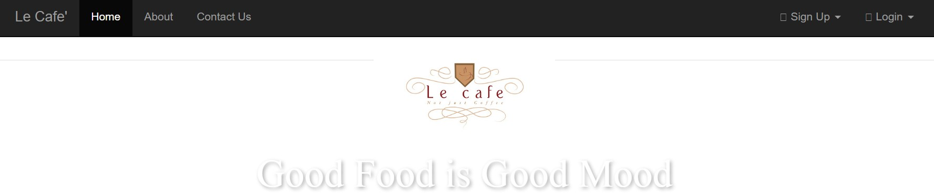

Contact Page

